Changes document for MS Decom activities

Project: Z_3F9F_QTML_MQ

System : xFE

CD: 151938.

Transport request: DFEK962733

—---------------------------------------------------------------------------------------------------------------------------------

1. Adding a new button as Export to my Drive in ManageQualification view.

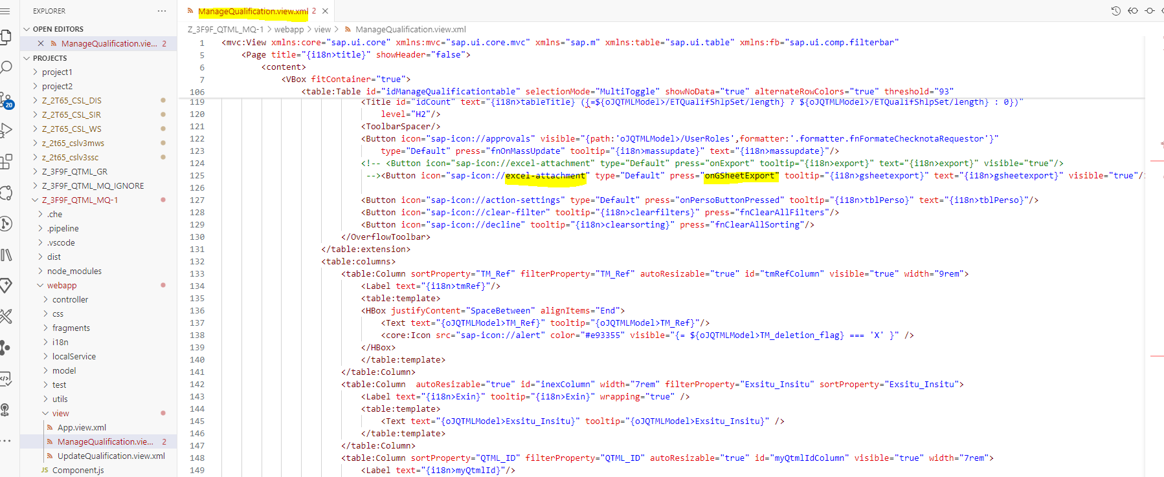

1. Below logic to fetch the data based on the filters from odata service and export it to google sheet.

